

Topic test 1
Name: __________________________________

Chapter 6: Trigonometric Functions

- Time allowed: 45 minutes
- CAS calculators may be used.
- Part A: 5 multiple-choice questions (5 marks)
- Part B: 7 short answer questions (38 marks)
- Part C: 2 analysis questions (11 marks)
Part A
5 multiple-choice questions
1 mark each: 5 marks
Circle the correct answer.
1 Find the amplitude and period of the following graph.
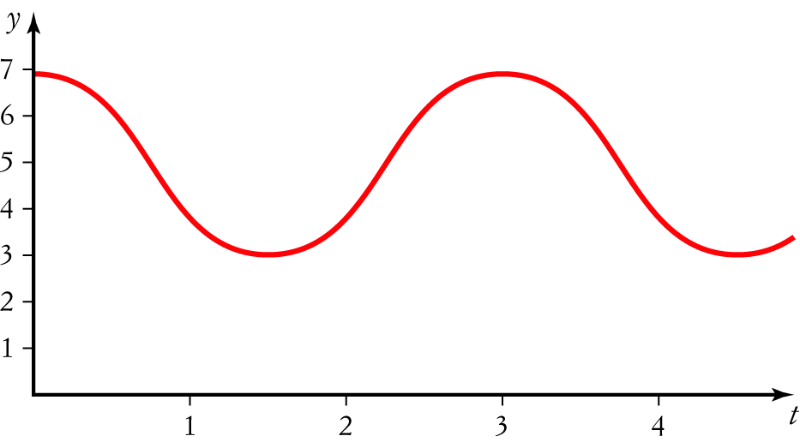
A Amplitude 4, period 4
B Amplitude 4, period 3
C Amplitude 4, period 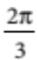
D Amplitude 2, period 3
E Amplitude 2, period

[1 mark]

2 The graph of y = tan (2x) is most like:
A 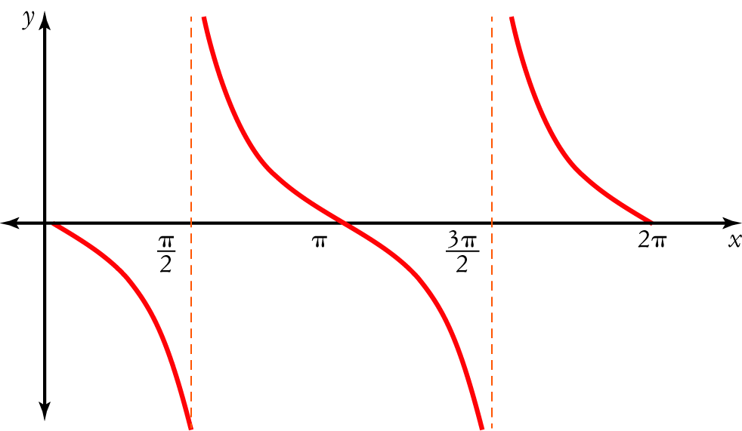
B 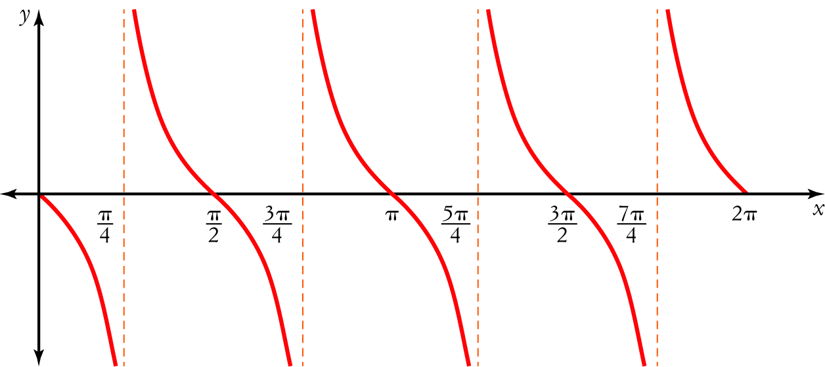
C 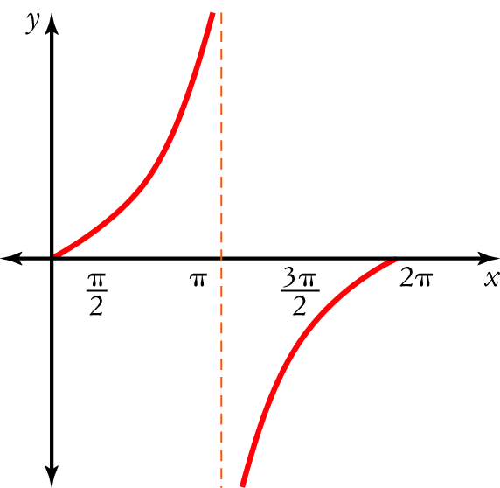
D 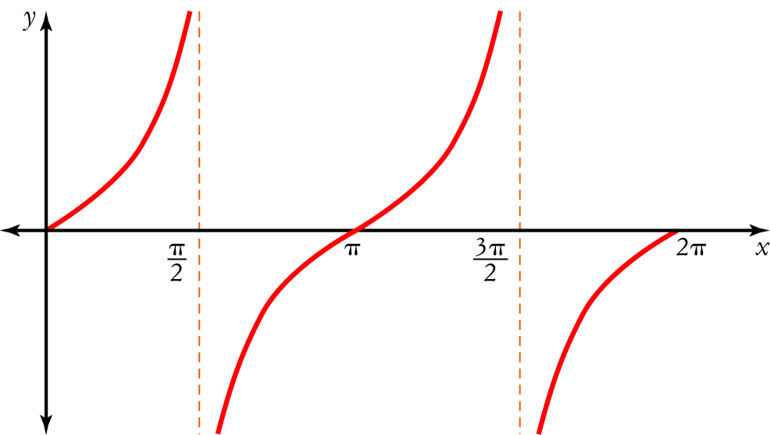
E 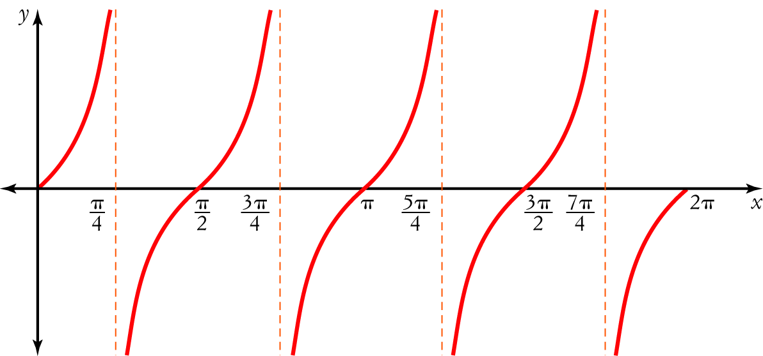

[1 mark]
3 Which statement is not correct?
A sin 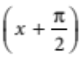  cos (x)
B cos 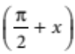  sin (x)
C cos 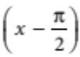  sin (x)
D sin 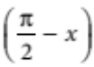  cos (x)
E cos  sin (x)

[1 mark]
4 Which statement is not correct?
A cos (x  y)  cos (x) cos (y)  sin (x) sin (y)
B sin (x  y)  sin (x) cos (y)  cos (x) sin (y)
C tan (x  y)  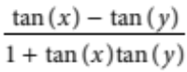
D sin (x  y)  sin (y) cos (x)  cos (y) sin (x)
E tan (x  y)  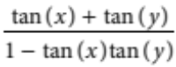

[1 mark]

5 The equation of the function below is:
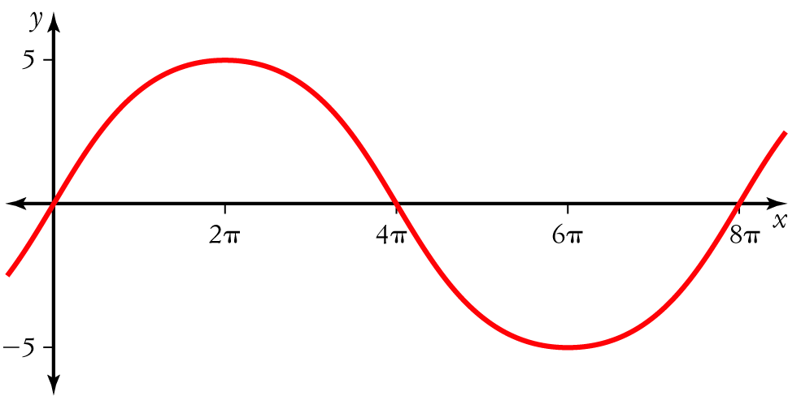
A y  8 sin (5 x)
B y  5 sin (8 x)
C y  5 sin 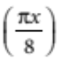
D y  5 sin 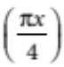
E y  5 sin (4πx)

[1 mark]
Part B
7 short answer questions
38 marks
Show your working where appropriate.
1 Find the value of
a tan (360°) ______________________________________________
b sin 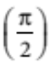 ______________________________________________
c cos (180°) ______________________________________________
d sin (2π) ______________________________________________
e tan (0°) ______________________________________________
[5 marks]

2 For the dmain 0 ≤ x ≤ 2, sketch the graph of:
a y  cos (x)

b y  2  sin (x)

c y  2 sin (x)  1

d y  6 cos 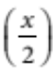

e y  tan 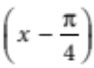

[10 marks]
3 If sin (a)  and cos (b)  , find the exact value of cos (a  b)

[5 marks]
4 By drawing the graphs of y  2 cos (x) and y  x  1 on the same set of axes, graphically solve
2 cos (x)  x  1. You may use a CAS calculator.

[4 marks]

5 Show that cos (2x)  1  2 sin2 (x)

[3 marks]

6 Solve for 0 ≤ x ≤ 2
a sin (x) 

b cos (x)  

[6 mark]
7 Solve 2 sin2 (θ)  1  0 for 0° ≤ θ ≤ 360°.

[5 marks]
Part C
2 analysis questions
11 marks
Show your working where appropriate.
1 Below is a table showing the average number of daylight hours over several months.
Month | Jan | Feb | Mar | Apr | May | Jun | Jul | Aug
Daylight hours | 15.3 | 14.7 | 13.2 | 13.1 | 12.7 | 12.2 | 12.5 | 13.8

a Draw a graph to display this data.

b Is it periodic? If so, what is the period?

c Find the amplitude.

d Approximately how many daylight hours would you expect there to be in November?

[6 marks]
2 The sales, S, in 100s of units, of a seasonal product are modelled by
S  54.8  32.5 cos 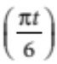
where t is the time in months (t  1 is January and t  12 is December).
a Sketch a graph of the sales for a period of 12 months.

b Use the graph to find the months when sales were greater than 6800 units.

[5 marks]
Total marks: 54

Answers
Part A [1 mark each]
1 Amplitude  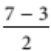  2
Period  3
∴ D [1 mark]
2 Period  
∴ E [1 mark]
3 sin  cos (x) and cos  sin (x) (phase changes)
sin  cos (x) and cos  sin (x) (from right-angled triangle)
∴ B [1 mark]
4 sin (x  y)  sin (x) cos (y)  cos (x) sin (y)
∴ D [1 mark]
5 Amplitude  5
Period  8
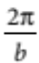  8
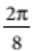  b
 8
y  a sin (bx)
 5 sin
∴ D [1 mark]
Part B
1 a tan (360°)  0 [1 mark]
b sin  1 [1 mark]
c cos (180°)  1 [1 mark]
d sin (2π)  0 [1 mark]
e tan (0°)  0 [1 mark]

2 a Period  2π, amplitude 1 [1 mark]
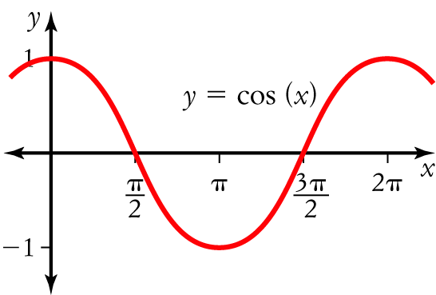 [1 mark]

b Period  2π, amplitude 1,  sin (x) is reflected in the x-axis, translated 2 units up. [1 mark]
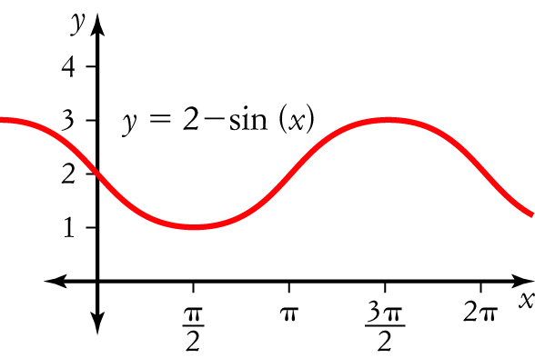 [1 mark]
c Period  2π, amplitude  2, translated 1 unit down. [1 mark]
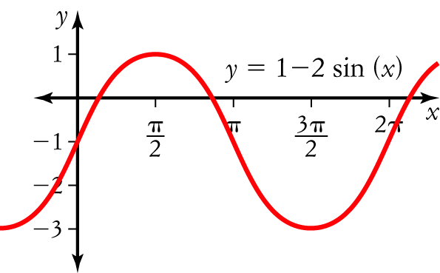
[1 mark]
d Period  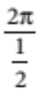  4π, amplitude  6 [1 mark]
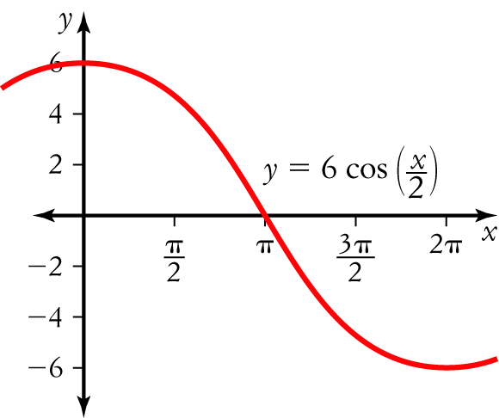 [1 mark]

e The graph y  tan (x) is translated units to the right. [1 mark]
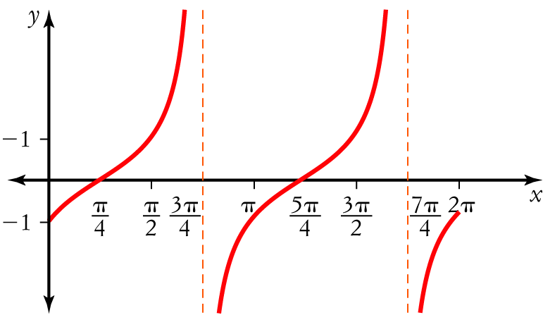
[1 mark]
3 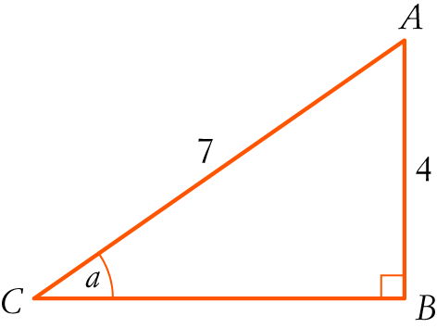 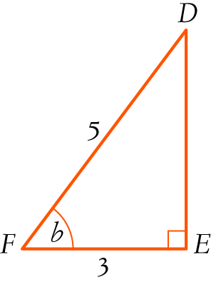
CB2  72  42  33
CB  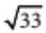 [1 mark]
DE  4 (3-4-5 triangle) [1 mark]
cos (a  b)  cos (a) cos (b)  sin (a) sin (b) [1 mark]
 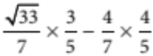 [1 mark]
 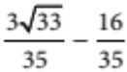
 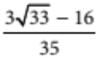 [1 mark]
4 On the CAS calculator or freehand, draw both graphs.
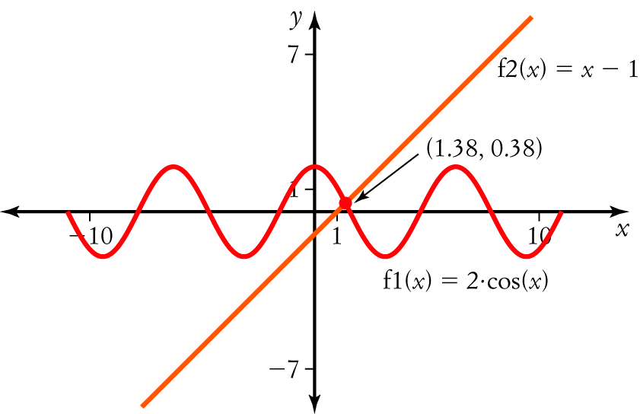
[3 marks]
x  1.4 [1 mark]
5 cos (2x)  cos (x  x)
 cos (x) cos (x)  sin (x) sin (x) [1 mark]
 cos2 (x)  sin2 (x) [1 mark]
 1  sin2 (x)  sin2 (x)
 1  2 sin2 (x) [1 mark]
6 a From the special triangle, sin 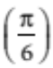  [1 mark]
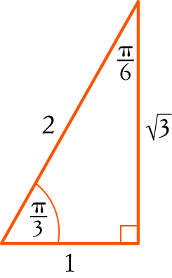
x  , π  (sin is positive in 1st, 2nd quadrants) [1 mark]
 , 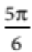 [1 mark]
b From the triangle, cos 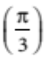  [1 mark]
x  π  , π  (cos is negative in 2nd, 3rd quadrants) [1 mark]
 , 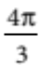 [1 mark]
7 2 sin2 (θ)  1
sin2 (θ)  [1 mark]
sin (θ)   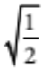
  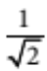 [1 mark]
From the special triangle, sin (45°) 
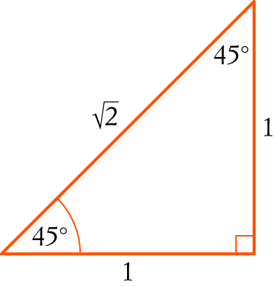
θ  45°, 180°  45°, 180°  45°, 360°  45° (all quadrants) [2 marks]
 45°, 135°, 225°, 315° [1 mark]
Part C
1 a 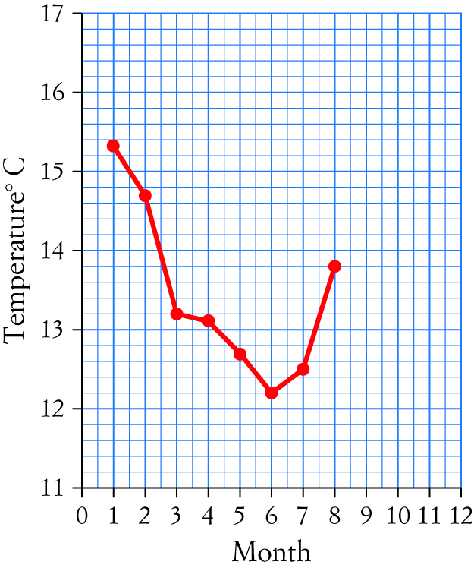
[3 marks]
b It is hard to tell if this graph is periodic without more data, but common sense says it would
be 12 months. [1 mark]
c Amplitude  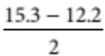 ≈ 1.6 [1 mark]
d In November you would expect the number of daylight hours to increase, say to around
15 hours, from extrapolating the graph. [1 mark]
2 a Period  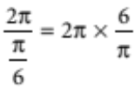  12; amplitude  32.5; the graph is translated 54.8 units upwards. [1 mark]
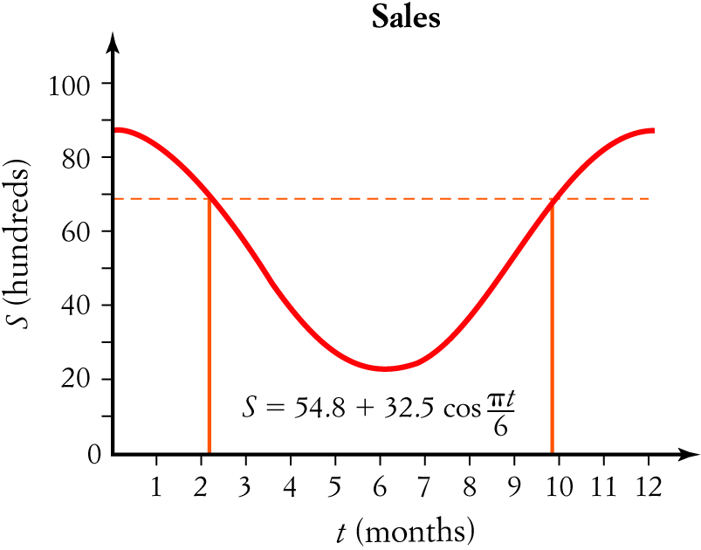
[2 marks]
b Draw a horizontal line across the graph at 6800.
The months that exceed 6800 units are Jan, Feb, Oct, Nov and Dec. [2 marks]

